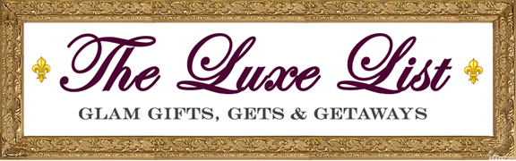

Radio - TRAVEL DESTINATIONS
WCTC-AM "Jersey Central" Show (January 2017 x2 and beyond)
Michelle Esswein Show (Syndicated: Z107.7 KLOU103.3 THEBULL93.7 WILD104.9 _i Heart Radio )
September Living Radio Show - part 1
September Living Radio Show - part 2
RadioVision Network’s Morning Coffee Program
Newsradio 600WMT Morning Show, Des Moines, IA
Connemara Community Radio Ireland: ‘The Food Show’. With Janet O’Toole
PANJ Rock On Radio Kenny Dubman Show
VinVillageRadio - 3/7/17
Experience Pros Radio Show
Radio - PRODUCTS
All Tech Radio (AM 1360 KUIK Hillsboro, Oregon + AM 860 KPAM in Portland, Oregon + Heavy Podcast Downloads)
Michelle Esswein Show (Syndicated: Z107.7 KLOU103.3 THEBULL93.7 WILD104.9 _i Heart Radio )
WCTC-AM "Jersey Central" Show
RadioVision Network’s Morning Coffee Program
LA Talk Radio
WATD FM, Marshfield, MA
Hardly Workin with Greg Burton ESPN 950 WXG, Richmond, VA
WINT Radio Wake Up Show (IA)
WJON St. Cloud, MN
WCTC-AM Jersey Central
WHO-AM Des Moines, IA
900 AM WURD - Philadelphia PA
The Derrell Connor Show - 620 WTMJ Milwaukee, Wisconsin
LA Talk Radio

